Unit #3
Study Guide

Grade 6

Links for online practice:

Free online tutorial, how-to, quizzes
Online Practice

Unit 3 Study Guide
In the coming weeks you will be assessed on Unit 3 of our mathematics curriculum. We developed this guide to help you to prepare for the assessment. This study guide includes the major content standards addressed in the unit.

The Unit 3 Assessment will be given the week of:__3/24/14____.
Sincerely,

Dear Students,

How to videos:
Learn Zillion Videos/Lessons

Khan Academy Videos/Tutorials
Equations and Inequalities

OVERVIEW OF UNIT:
In this unit, students will write, solve, and graph equations and inequalities. They will apply formulas to find area, surface area, and volume of polygons in real-world problems.
Standards and Using Online Resources
In order to use online practice tutorials and sites, you will have to enter the standard. In this unit you will be learning standards: 6.EE.5, 6.EE.6, 6.EE.7, 6.EE.8

For More information about the Common Core Standards, go to:
http://www.corestandards.org and http://curriculum.northsmithfieldschools.com

Overview of Unit

Printable Practice 6.EE.5

Understand solving an equation or inequality as a process of answering a question: which values from a specified set, if any, make the equation or inequality true? 6.EE.5
Watch a How-To Video Click Here for More Practice With This Standard

1. Of the numbers 6, 7, or 8, which is a solution of the inequality f + 2 < 9?

Show your work on a separate piece of paper.

2. Of the numbers 8, 9, or 10, which is a solution of the inequality n - 3 > 6?

Show your work on a separate piece of paper.

3. A bakery is keeping track of the number of bagels sold each day.

If the bakery sells more than 45 bagels in a day, they make a profit.

Use the inequality b > 45 to determine which days the bakery makes

a profit.

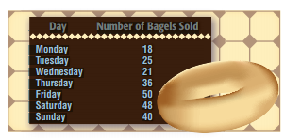

4. Antonio has decided that he just wants to ride the go-cart ride with his $20. How many times could Antonio ride the go-carts if each ride costs $5.50? Could Antonio ride 5 times? Why or why not? Could he ride 3 times? Why or why not?

Write an inequality to represent the scenario and generate a list of potential solutions.

Show your work on a separate piece of paper.
Unit 3 Study Guide
Printable Practice 6.EE.6

Show Me Video 6.EE.6

Use variables to represent numbers and write expressions when solving a real-world or mathematical problem 6.EE.6
Watch a How-To Video Click Here for More Practice With This Standard

Show your work on a separate piece of paper.

5. Scott bought new shirts (s) for his hockey team. He gave 23 shirts to his friends. Write the expression that shows how many shirts Scott has now.

6. Sara has saved $20 more than 2 times the amount her brother has saved. Write an expression that represents the amount Shreya has saved.

Printable Practice 6.EE.7

Show Me Video 6.EE.7

Solve real-world and mathematical problems by writing and solving equations of the form x + p = q and px = q for cases in which p, q and x are all nonnegative rational numbers. 6.EE.7
Watch a How-To Video Click Here for More Practice With This Standard

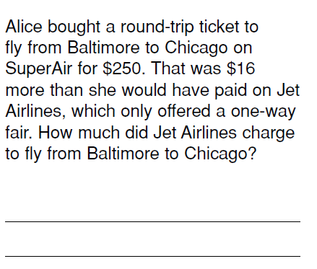

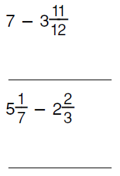
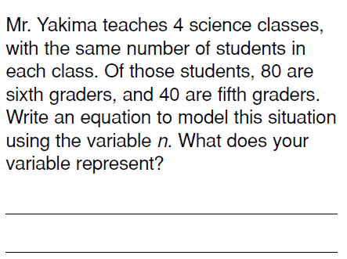

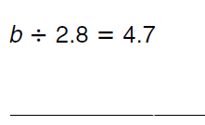
Solve each equation. Check your answers
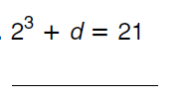
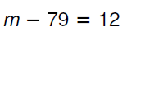

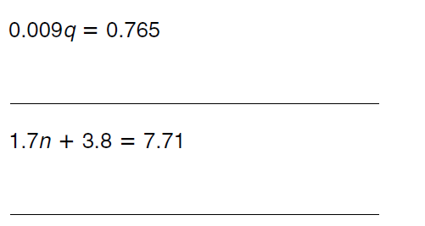

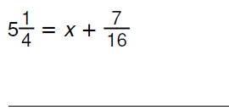

Unit 3 Study Guide
Printable Practice 6.EE.8

Show Me Video 6.EE.8

Write an inequality of the form x > c or X < c to represent a constraint or condition in a real-world or mathematical problem. Recognize that inequalities of the form x > c or x < c have infinitely many solutions; represent solutions of such inequalities on number line diagrams. 6.EE.8
Watch a How-To Video Click Here for More Practice With This Standard

7. Sharon is planning a party. She has $120 to spend.
The birthday hall charges a $60 fee for all parties and $5.75 for each person.

a) Write an inequality that represents Sharon’s situation.

b) How many people could come to the party without exceeding Sharon spending limit?

8. James wants to rent a bike. Bike rental charges are at the rate of $2.25 in addition to $ 0.30 per mile. James cannot spend more than $12 on ride.

a) Write an inequality that represent James situation.

b) How many miles can James travel without exceeding his limit?

9. Write an inequality for each sentence.

Swim practice will be no more than 35 laps.
Kevin ran for less than 5 miles.
You cannot spend more than 50 dollars.
The occupancy of the room must be less than 437 people.
More than 800 fans attended the opening soccer game.

Online Practice and Games That Teach
Expressions, Equations and Inequalities from AAA Math
The top of the page gives an explanation of the terms. Scroll to the end of the page for online practice and games.
Evaluating a 1 Variable Expression | Inequalities
Evaluating a 2 Variable Expression | Multiplication Sentences I
Equations 1 | Multiplication Sentences II
Equations 2 | Division Sentences I
Equations 3 | Division Sentences II
Equations 4 | Expressions, Equations and Inequalities Quiz
Equations 5
6th Grade Games - Reason about and solve one-variable equations and inequalities from MathChimp.com
Make 24
Use 4 cards and arithmetic signs to make a formula that equals 24.
Swimming Otters
Complete the expression and your otter might win the race!
Postie - Variables
Help the Postman Phil deliver letters by answering variables equations.
Expressions Billionaire
Get each question right for a chance to win one-billion dollars.
Soccer Equations
Solve each equation to get a chance to score a soccer goal.
Basketball Equations
Get baskets in and answer one-step math equations.
Number Balls Equations
Popular number balls game for equations with variables.
Quiz Show Inequalities
Answer questions about inequalities for your team to win.

