GRADE 6
Unit # 4
Study Guide

Unit 4 Study Guide
In the coming weeks you will be assessed on Unit 4 of our mathematics curriculum. We developed this guide to help you to prepare for the assessment. This study guide includes the major content standards addressed in the unit.

The Unit 4 Assessment will be given the week of: 5/12/14

Sincerely,
Grade Six Teachers

Links for online practice:

Free online tutorial, how-to, quizzes
Online Practice

Dear Students,

How to videos:
Learn Zillion Videos/Lessons

Khan Academy Videos/Tutorials
Rational Numbers
In this unit, students will recognize, understand, and position integers (positive and negative) on number lines and coordinate planes. They will use coordinates and absolute value to solve real-world and mathematical problems. Students will use coordinate planes to draw polygons and find distances between the points on the plane. They will display data in appropriate representations and summarize the distribution.
Standards and Using Online Resources
In order to use online practice tutorials and sites, you will have to enter the standard. In this unit you will be learning standards: 6.NS.6,
6.NS.7, 6.NS.8
For More information about the Common Core Standards, go to:
http://www.corestandards.org and http://curriculum.northsmithfieldschools.com

Overview of Unit

Show Me Video 6.NS.6
Show Me Video 6.NS.7

Printable Practice 6.NS.6
Printable Practice 6.NS.7

Apply and extend previous understandings of numbers to the system of rational numbers. 6.NS.6, 6.NS.7
Watch a How-To Video 6.NS.6 Click Here for More Practice With This Standard

Watch a How-To Video 6.NS.7 Click Here for More Practice With This Standard

1. Plot the following numbers on the number line.
$A=\frac{1}{4}$ , B = - $\frac{3}{5}$ , C = -$\frac{8}{2}$ , D =$\frac{15}{3}$

-4 -3 -2 -1 0 1 2 3 4 5

2. Which points are between -1 and +1?

3. Change the following fractions into decimals and plot.

Show work on separate piece of paper.
$-1\frac{2}{3}$ , $-$ $\frac{3}{4}$ , $-3$ $\frac{5}{8}$ , $- \frac{12}{4}$ , $-\frac{10}{2}$
-5 -4 -3 -2 -1 0
4. What is the missing number? __________
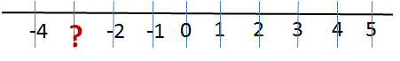
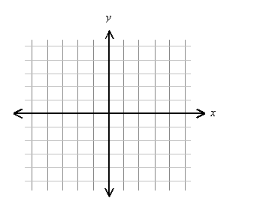
5. Plot point (5, 4) on a coordinate system and circle where the ordered pair is located.

- First Quadrant
- Second Quadrant
- Third Quadrant
- Fourth Quadrant
- Origin

6. Which ordered pair coordinates with point A on the grid?
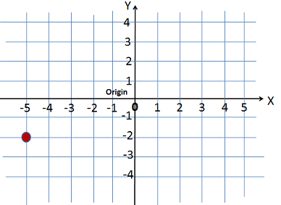
- -5, -3
- -5, -2
- -3, -3
- -2, -5
- -1, -5
- -5, 0
A

7. Place a >, <, or = symbol on each line to compare the rational numbers below.

$-\frac{2}{3}$ _____ .6 -11 _____ -17 -4.3_____ 3.4 $-\frac{1}{4}$ _____ $-\frac{1}{8}$
8. Place the following numbers in order from greatest to least: -8$\frac{1}{16}$, 0.9, -9.4
_________, _________, _________

9. Place the following numbers in order from least to greatest: 7, 0.4, - 4.1

_________, _________, _________

10. Which of the decimals has the greatest value?

- 0.5
- 0.05
- 0.059
- 0.56
- 0.519

11. Compare using <, >, or = .

|3| |-3|

12.
a. Graph the polygon with the given coordinates.
6

A= (4, 4)

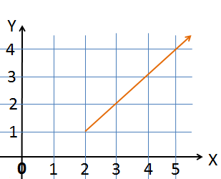
B= (-4, 4)
C= (4, -6)

D= (-4, -6)

-6
6
b. What is the perimeter?

A= 80 units

B= 36 units

C= 24 units
-6

D= 14 units

Unit 4 Study Guide
Show Me Video 6.NS.8

Printable Practice 6.NS.8

Apply and extend previous understandings of numbers to the
system of rational numbers. 6.NS.8
Watch a How-To Video Click Here for More Practice With This Standard

13. Some points are shown in the coordinate plane below.
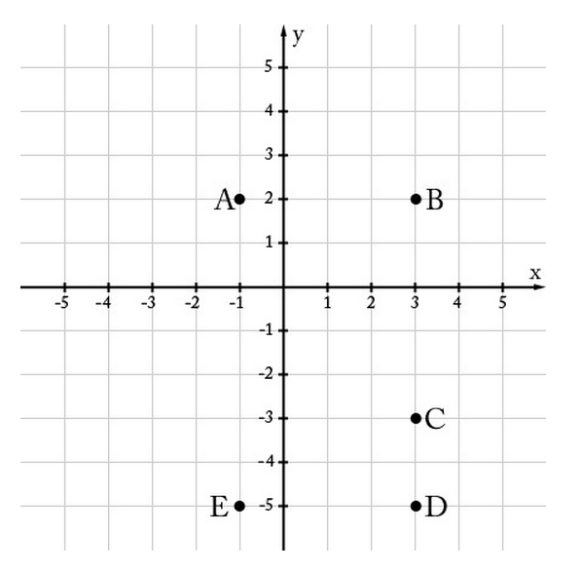

- What is the ordered pair for point A ? ( , )
- What is the ordered pair for point E ? ( , )
- What is the distance between points B & C? _______________
- What is the distance between points D & B? _______________
- What is the distance between points D & E? _______________
- Which of the points shown above are 4 units away from ( -1, -3)
and 2 units away from (3, -1)? _____ ________________________

